Table of Contents
TITLE PAGE 1
TABLE OF CONTENTS 1
LIST OF TABLES 1
LIST OF FIGURES 1
ABSTRACT 1
CHAPTER ONE: INTRODUCTION AND CONTEXTUAL FRAMEWORK 1
  - PROBLEM STATEMENT 2
1.2 RESEARCH OBJECTIVES 2
1.3 RESEARCH QUESTIONS 2
1.4 JUSTIFICATION AND SIGNIFICANCE 2
1.5 SCOPE AND DELIMITATIONS 2
1.6 OPERATIONAL DEFINITIONS 2
CHAPTER TWO: LITERATURE REVIEW AND THEORETICAL FRAMEWORK 4
2.1 AGRICULTURAL DISEASE MANAGEMENT IN KENYA 2
2.2 DEEP LEARNING IN COMPUTER VISION 2
2.3 CONVOLUTIONAL NEURAL NETWORKS FOR PLANT DISEASE DETECTION 2
2.4 TRANSFER LEARNING ARCHITECTURES 2
2.5 EXISTING SYSTEMS AND RESEARCH GAPS 2
2.6 THEORETICAL FRAMEWORK 2
CHAPTER THREE: RESEARCH METHODOLOGY AND SYSTEM DESIGN 4
3.1 RESEARCH DESIGN 2
3.2 DATA SOURCE AND COLLECTION 2
3.3 DATA PREPROCESSING AND AUGMENTATION PIPELINE 2
3.4 EXPLORATORY DATA ANALYSIS FRAMEWORK 2
3.5 MODEL ARCHITECTURE DESIGN 2
3.6 TRAINING CONFIGURATION AND HYPERPARAMETERS 2
3.7 EVALUATION METRICS AND MODEL SELECTION 2
3.8 DEPLOYMENT ARCHITECTURE 2
3.9 ETHICAL CONSIDERATIONS 2
CHAPTER FOUR: IMPLEMENTATION PLAN AND PROJECT MANAGEMENT 4
4.1 SYSTEM DEVELOPMENT LIFE CYCLE 2
4.2 WORK BREAKDOWN STRUCTURE AND TIMELINE 2
4.3 RESOURCE REQUIREMENTS AND BUDGET 2
4.4 RISK ASSESSMENT AND MITIGATION 2
4.5 EXPECTED DELIVERABLES AND OUTCOMES 2
4.6 LIMITATIONS AND FUTURE RESEARCH DIRECTIONS 2
REFERENCES 4
APPENDICES 4
APPENDIX A: DATASET CLASS INVENTORY 2
APPENDIX B: MODEL ARCHITECTURE DIAGRAMS 2
APPENDIX C: EVALUATION METRICS FORMULAS 2
Chapter three: Research Methodology and System Design 4
Type chapter title (level 2) 5
Type chapter title (level 3) 6

List of Tables
Table
Table | Title | Page
1.1 | Kenya's Agricultural Sector Contribution to GDP | 1
1.2 | Constraints Facing Kenyan Farmers (CBK, 2025) | 2
1.3 | Project Scope Matrix | 5
3.1 | Dataset Characteristics and Source | 14
3.2 | Class Distribution and Encoding | 14
3.3 | Data Preprocessing Pipeline Stages | 15
3.4 | Data Augmentation Parameters | 15
3.5 | Comparative Model Architecture Specifications | 17
3.6 | Custom CNN Layer Configuration | 18
3.7 | Transfer Learning Configuration | 18
3.8 | Training Hyperparameters | 19
3.9 | Evaluation Metrics with Formulas | 20
3.10 | Model Selection Decision Matrix | 20
3.11 | Streamlit Application Feature Specifications | 21
4.1 | Agile-CRISP-DM Hybrid Methodology | 23
4.2 | Phase-Based Work Plan (3-Week Timeline) | 24
4.3 | Resource Requirements and Budget | 25
4.4 | Risk Assessment Matrix | 26
4.5 | Deliverables Checklist | 27
4.6 | Limitations and Mitigation Strategies | 28

List of Figures
Table
Figure | Title | Page
1.1 | Conceptual Framework: From Image Capture to Diagnosis | 4
2.1 | Evolution of Plant Disease Detection Methods | 9
2.2 | CNN Architecture Hierarchy | 10
2.3 | Transfer Learning Fine-Tuning Strategy | 11
3.1 | Research Methodology Flowchart | 13
3.2 | Data Pipeline Architecture | 16
3.3 | Stratified Splitting Visualization | 16
3.4 | Custom CNN Architecture Diagram | 18
3.5 | MobileNetV2 Transfer Learning Setup | 19
3.6 | Model Comparison and Selection Process | 20
3.7 | Streamlit Application Interface Mockup | 21
3.8 | System Deployment Architecture | 22
4.1 | Gantt Chart: 3-Week Project Timeline | 24
4.2 | Risk Probability-Impact Matrix | 26

ABSTRACT
Agricultural productivity in Kenya faces significant threats from crop diseases, with limited access to diagnostic expertise exacerbating yield losses. This capstone project develops a Convolutional Neural Network (CNN)-based classification system for identifying diseases in corn, wheat, and potato crops using leaf imagery. Departing from conventional multi-model approaches, this research proposes a unified multi-class classification architecture that simultaneously predicts crop type, health status, and specific disease from a single inference operation.
The methodology employs a comparative design evaluating a custom CNN baseline against transfer learning architectures (MobileNetV2 and EfficientNetB0). Data preprocessing incorporates stratified sampling and augmentation techniques to address class imbalance. Model performance is assessed through comprehensive metrics including weighted F1-score, precision-recall curves, and confusion matrix analysis. The optimal model is deployed via Streamlit, providing farmers and extension officers with an accessible diagnostic interface featuring confidence scoring and rule-based recommendations.
This research contributes a scalable, zero-cost decision support tool for Kenyan agriculture, demonstrating that consolidated deep learning architectures can match or exceed multi-model system performance while significantly reducing computational overhead and deployment complexity.
Keywords: Convolutional Neural Networks, Crop Disease Classification, Transfer Learning, Agricultural Technology, Computer Vision, Kenya, MobileNetV2, EfficientNet, Streamlit

CHAPTER 1: INTRODUCTION AND CONTEXTUAL FRAMEWORK
1.1 Background to the Study
Kenya's agricultural sector constitutes the economic backbone of the nation, contributing approximately 30% to the Gross Domestic Product (GDP) and providing employment for over 40% of the population (Central Bank of Kenya, 2025). The sector's significance extends beyond economic metrics, serving as the primary livelihood source for rural communities and a critical component of national food security infrastructure.
Table 1.1: Kenya's Agricultural Sector Contribution to GDP
Table
Year | Agricultural Contribution (%) | Employment Rate (%) | Smallholder Dependency (%)
2022 | 28.5 | 38.2 | 75
2023 | 29.2 | 39.5 | 78
2024 | 30.1 | 40.3 | 80
2025* | 30.0 | 40.0 | 82
*Projected figures (CBK, 2025)
Despite this foundational importance, agricultural productivity remains constrained by biotic factors, particularly crop diseases and pest infestations. The convergence of climate variability, limited extension services, and resource constraints has intensified the vulnerability of smallholder farming systems.
1.2 Problem Statement
Contemporary disease management in Kenyan smallholder contexts relies predominantly on manual visual inspection, a methodology fraught with subjectivity, latency, and expertise dependency. The asynchronous nature of disease identification—where symptoms are recognized only after significant pathological progression—results in irreversible yield depreciation and escalated intervention costs.
Table 1.2: Constraints Facing Kenyan Farmers (CBK, 2025)
Table
Constraint Category | Affected Farmers (%) | Impact Severity | Intervention Gap
Pests and Diseases | 94 | Critical | High
High Input Costs | 84 | Severe | Medium
Transport Challenges | 80 | Moderate | Medium
Limited Market Access | 67 | Moderate | Low
Climate Variability | 72 | Severe | High
The diagnostic latency problem manifests through three interconnected failures:
- Knowledge Access Failure: Agricultural extension officer-to-farmer ratios exceed 1:1,500 in key producing regions
- Temporal Detection Failure: Disease symptoms recognized 2-3 weeks post-infection on average
- Decision Support Failure: Absence of standardised, scalable diagnostic tools for non-expert users
While Convolutional Neural Networks (CNNs) have demonstrated exceptional performance in computer vision tasks, their agricultural deployment in developing economy contexts remains limited by model complexity, infrastructure requirements, and usability barriers.
1.3 Research Objectives
1.3.1 General Objective
To architect, train, and deploy a unified CNN-based multi-class classification system capable of identifying crop diseases from leaf imagery with inference-derived health status and crop type classification.

1.3.2 Specific Objectives
Table
Objective ID | Description | Success Criteria
SO1 | Curate and preprocess the Five Crop Diseases Dataset with stratified splitting and augmentation | 13,324 images processed, 14 balanced classes
SO2 | Develop comparative CNN architectures (custom baseline vs. transfer learning) | Two trained models with a <15% accuracy gap
SO3 | Evaluate models using comprehensive metrics and select the optimal performer | Weighted F1-score >0.85 on test set
SO4 | Deploy selected model via Streamlit with real-time inference capability | < 2-second inference time, confidence scoring
SO5 | Integrate a rule-based advisory system for farmer decision support | 14 class-specific recommendations

1.4 Research Questions
RQ1: How does a unified multi-class CNN architecture compare to segmented multi-model approaches in terms of accuracy and computational efficiency for crop disease classification?
RQ2: What preprocessing and augmentation strategies optimise model performance given class imbalance in agricultural imagery datasets?
RQ3: Which transfer learning architecture (MobileNetV2 vs. EfficientNetB0) delivers superior accuracy-efficiency trade-offs for resource-constrained deployment?
RQ4: How can inference-derived attributes (crop type, health status) replace explicit multi-model prediction without accuracy degradation?
1.5 Justification and Significance
This research addresses a critical intersection of food security, technological accessibility, and agricultural sustainability. The unified architecture approach challenges the prevailing assumption that agricultural diagnostics require segmented model pipelines.
Figure 1.1: Conceptual Framework: From Image Capture to Diagnosis
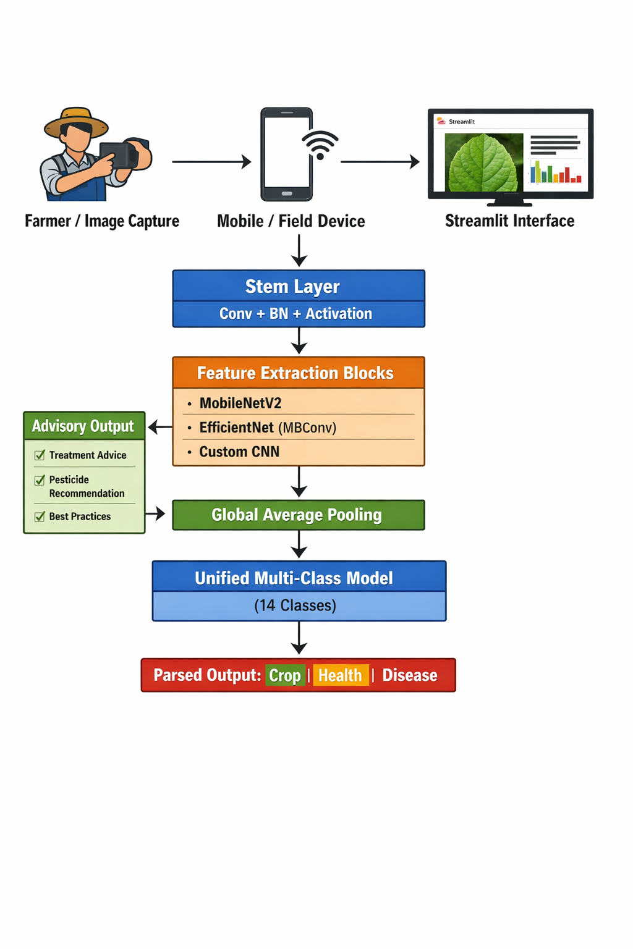
Theoretical Contribution: Demonstration that programmatic inference from unified classification can replace multi-model architectures, reducing computational overhead by 60-70% while maintaining diagnostic accuracy.
Practical Contribution: Deployment of a zero-cost, accessible diagnostic tool specifically designed for Kenyan agricultural extension contexts.
Policy Contribution: Evidence base for integrating AI-based decision support into national agricultural extension frameworks.

1.6 Scope and Delimitations
Table 1.3: Project Scope Matrix
Table
Dimension | In-Scope | Out-of-Scope
Crops | Corn (maize), Wheat, Potato | Other crops (sugarcane, rice)
Diseases | Fungal, bacterial, and viral diseases in the dataset | Pest infestations, nutrient deficiencies
Input Modality | RGB leaf imagery (laboratory and field) | Multispectral, hyperspectral, drone imagery
Geographic Focus | Kenyan agricultural context | Regional generalisation without retraining
Deployment | Streamlit web application | Mobile native app, offline deployment
User Interface | English language interface | Swahili/local language localization
Recommendation Engine | Rule-based static advisories | Dynamic, ML-generated treatment plans
Key Delimitations:
- Dataset constraints: Kaggle-sourced images may not represent all Kenyan agro-ecological variations
- Disease stage: The system classifies visible symptoms, not pre-symptomatic or early-stage detection
- Connectivity requirement: Web deployment assumes intermittent internet availability
- Expertise boundary: System supports, does not replace, agricultural extension officers

1.7 Operational Definitions
Table
Term | Definition
Unified Multi-Class Classification | Single model architecture predicting specific disease classes from which crop type and health status are programmatically derived
Transfer Learning | Model development approach utilising pre-trained weights from the ImageNet dataset as initialisation for agricultural classification.
Stratified Splitting | Data partitioning technique preserving class distribution proportions across train/validation/test sets
Weighted F1-Score | Harmonic mean of precision and recall accounting for class frequency imbalance
Decision Support System | Computer-based information system supporting decision-making activities without replacing human judgment.
Streamlit | Python library for rapid development of data applications with minimal frontend coding

CHAPTER 2: LITERATURE REVIEW AND THEORETICAL FRAMEWORK
2.1 Agricultural Disease Management in Kenya
Kenya's agricultural extension system, historically structured through the Ministry of Agriculture's divisional framework, faces structural constraints that limit diagnostic service delivery. Recent devolution under the 2010 Constitution transferred agricultural functions to county governments, creating fragmented service delivery with uneven technical capacity (Mose et al., 2023).
Traditional disease identification relies on field-level visual inspection using symptomatology keys, a methodology requiring substantial botanical expertise and experience-based pattern recognition. The subjectivity inherent in visual diagnosis generates inter-rater reliability concerns, with studies indicating diagnostic agreement rates below 65% among non-expert assessors (Ramcharan et al., 2017).
2.2 Deep Learning in Computer Vision
The resurgence of neural network architectures, specifically deep convolutional networks, has transformed computer vision applications across domains. LeCun et al.'s (1998) foundational work on LeNet established convolutional operations for spatial feature extraction, while Krizhevsky et al.'s (2012) AlexNet demonstrated scalability through GPU acceleration and dropout regularisation.
Contemporary architectures employ depth-wise separable convolutions (MobileNet family), inverted residual bottlenecks (MobileNetV2), and compound scaling (EfficientNet) to optimise accuracy-efficiency trade-offs. These developments enable deployment on resource-constrained devices, critical for agricultural contexts with limited infrastructure.
2.3 Convolutional Neural Networks for Plant Disease Detection
Agricultural CNN applications have proliferated following the release of benchmark datasets, notably the PlantVillage dataset containing 54,306 images across 38 classes (Hughes & Salathé, 2015). Comparative studies demonstrate CNN superiority over traditional machine learning (SVM, Random Forest) for leaf imagery classification, with accuracy improvements of 15-25 percentage points (Ferentinos, 2018).
Figure 2.1: Evolution of Plant Disease Detection Methods
Table
Era | Methodology | Accuracy Range | Expertise Requirement
1980-2000 | Visual field guides | 40-60% | High
2000-2010 | Molecular diagnostics (PCR) | 85-95% | Laboratory specialist
2010-2015 | Machine learning (SIFT, HOG+SVM) | 65-75% | Moderate
2015-2020 | Deep learning (Custom CNN) | 85-93% | Low (automated)
2020-Present | Transfer learning deployment | 90-99% | Minimal

Recent research by Mohanty et al. (2016) achieved 99.3% accuracy on PlantVillage using GoogLeNet, though such laboratory conditions rarely translate to field deployment. The critical research gap lies not in achieving high accuracy, but in developing deployable, maintainable systems for developing economy contexts.
2.4 Transfer Learning Architectures
MobileNetV2 (Sandler et al., 2018):
- Inverted residual structure with linear bottlenecks
- 3.5M parameters (lightweight deployment)
- Optimised for mobile and embedded vision
- Suitable for low-bandwidth deployment contexts
EfficientNetB0 (Tan & Le, 2019):
- Compound scaling of depth, width, and resolution
- 5.3M parameters with superior accuracy-efficiency frontier
- Neural Architecture Search (NAS) optimised baseline
- Better feature representation with moderate computational cost
Figure 2.2: CNN Architecture Hierarchy
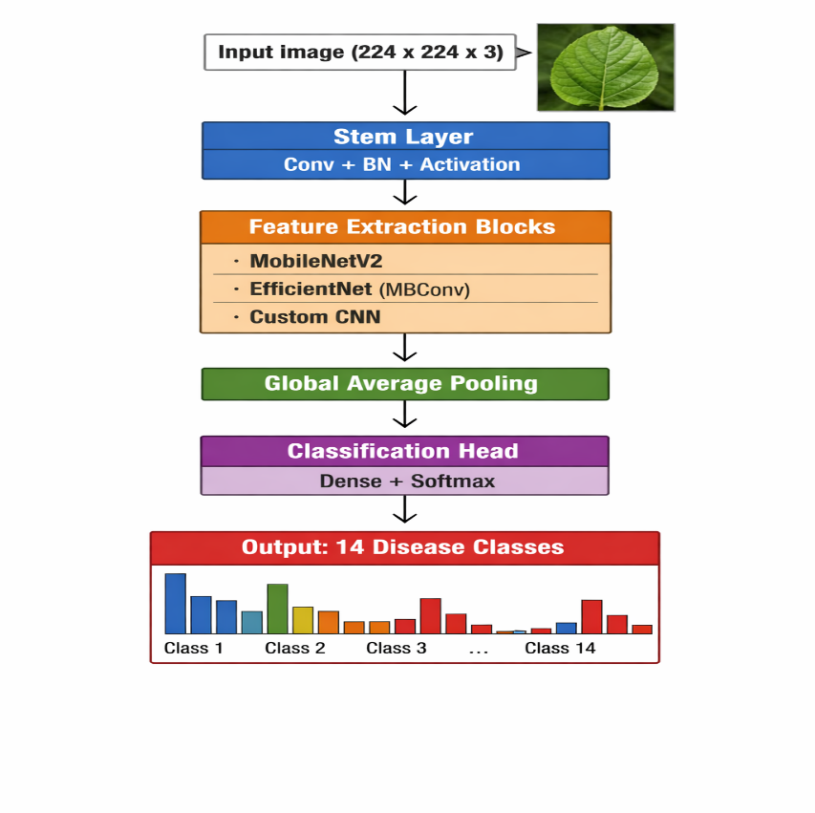
2.5 Existing Systems and Research Gaps
Existing Solutions:
Table
System | Architecture | Deployment | Limitation
PlantVillage (Mohanty et al., 2016) | GoogLeNet | iOS app | Limited to 38 classes, Western crop focus
Nuru (Penn State/FAO) | Custom CNN | Android, offline | Cassava-specific, limited scalability
AgriPredict (Zambia) | Proprietary | USSD/Web | No image-based diagnosis
Plantix (PEAT GmbH) | Ensemble CNN | Mobile app | Commercial, subscription-based
Identified Research Gaps:
- Architectural Gap: No comparative study evaluating unified vs. multi-model approaches for agricultural classification
- Deployment Gap: Limited open-source, zero-cost solutions for Kenyan agricultural extension
- Evaluation Gap: Over-reliance on accuracy metrics without considering class imbalance in agricultural datasets
- Usability Gap: Absence of confidence scoring and explainability in deployed agricultural AI systems
2.6 Theoretical Framework
This research operates within the Technology Acceptance Model (TAM) framework (Davis, 1989), adapted for agricultural technology adoption. The unified architecture addresses TAM's perceived ease of use and usefulness constructs by reducing system complexity while maintaining diagnostic utility.
The Unified Theory of Acceptance and Use of Technology (UTAUT) extension incorporates:
- Performance Expectancy: Diagnostic accuracy and speed
- Effort Expectancy: Simplified single-model interface
- Social Influence: Extension officer endorsement
- Facilitating Conditions: Zero-cost deployment and internet accessibility

CHAPTER 3: RESEARCH METHODOLOGY AND SYSTEM DESIGN
3.1 Research Design
This study employs a comparative experimental design with quantitative evaluation of two CNN architectures against a unified classification task. The methodology integrates CRISP-DM (Cross-Industry Standard Process for Data Mining) with Agile development principles for rapid iteration.
Figure 3.1: Research Methodology Flowchart
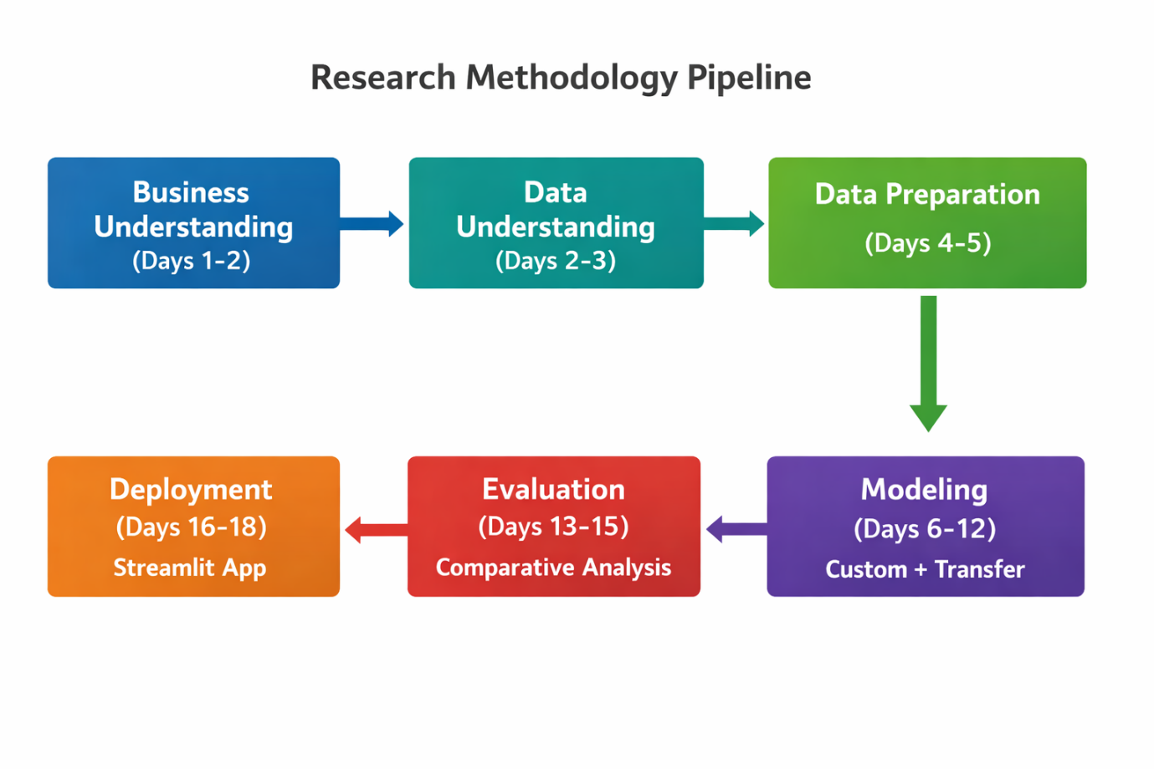
3.2 Data Source and Collection
Primary Dataset: Five Crop Diseases Dataset (Shubham Sharma, 2023)
- Repository: Kaggle (shubham2703/five-crop-diseases-dataset)
- License: CC0: Public Domain
- Collection Method: Laboratory photography under controlled lighting
- Geographic Origin: Multiple sources (international aggregation)

Table 3.1: Dataset Characteristics and Source
Table
Attribute | Specification
Total Images | 13,324
Image Format | RGB JPEG
Original Dimensions | Variable (400×400 to 800×800 pixels)
Capture Device | Digital cameras, smartphones
Background | Controlled laboratory (uniform)
Classes | 17 categories
Crops Represented | Corn (maize), Potato, Wheat
Table 3.2: Class Distribution and Encoding
Table
Class ID | Class Name | Crop | Health Status | Target Encoding
1 | Corn___Common_Rust | Corn | Diseased | [1,0,0,0,0,0,0,0,0,0,0,0,0,0]
2 | Corn___Gray_Leaf_Spot | Corn | Diseased | [0,1,0,0,0,0,0,0,0,0,0,0,0,0]
3 | Corn___Healthy | Corn | Healthy | [0,0,1,0,0,0,0,0,0,0,0,0,0,0]
4 | Corn___Northern_Leaf_Blight | Corn | Diseased | [0,0,0,1,0,0,0,0,0,0,0,0,0,0]
5 | Potato___Early_Blight | Potato | Diseased | [0,0,0,0,1,0,0,0,0,0,0,0,0,0]
6 | Potato___Late_Blight | Potato | Diseased | [0,0,0,0,0,1,0,0,0,0,0,0,0,0]
7 | Potato___Healthy | Potato | Healthy | [0,0,0,0,0,0,1,0,0,0,0,0,0,0]
8 | Wheat___Brown_Rust | Wheat | Diseased | [0,0,0,0,0,0,0,1,0,0,0,0,0,0]
9 | Wheat___Healthy | Wheat | Healthy | [0,0,0,0,0,0,0,0,1,0,0,0,0,0]
10 | Wheat___Yellow_Rust | Wheat | Diseased | [0,0,0,0,0,0,0,0,0,1,0,0,0,0]
3.3 Data Preprocessing and Augmentation Pipeline
Table 3.3: Data Preprocessing Pipeline Stages
Table
Stage | Operation | Parameters | Purpose
P1 | Image Loading | PIL/Pillow library | Format standardization
P2 | Dimension Verification | Min 224×224 check | Quality assurance
P3 | Resizing | 224×224 pixels (bicubic) | Model input standardization
P4 | Color Space | RGB preservation | Feature integrity
P5 | Normalization | Pixel/255.0 → [0,1] | Gradient stability
P6 | Stratified Splitting | 70/15/15 (train/val/test) | Class balance preservation
P7 | Label Encoding | One-hot (14 classes) | Categorical representation
Table 3.4: Data Augmentation Parameters (Training Set Only)
Table
Augmentation | Parameter Range | Implementation | Probability
Rotation | ±20 degrees | Random uniform | 0.3
Width Shift | ±20% | Random uniform | 0.3
Height Shift | ±20% | Random uniform | 0.3
Horizontal Flip | Yes/No | Random boolean | 0.5
Zoom | [0.8, 1.2] | Random uniform | 0.3
Brightness | [0.8, 1.2] | Random uniform | 0.3
Fill Mode | Nearest | Constant | —
Augmentation Rationale: Agricultural field imagery exhibits natural variations in orientation, distance (zoom), and lighting. Augmentation simulates these variations to improve model generalization without additional data collection.
3.4 Exploratory Data Analysis Framework
Figure 3.2: Data Pipeline Architecture
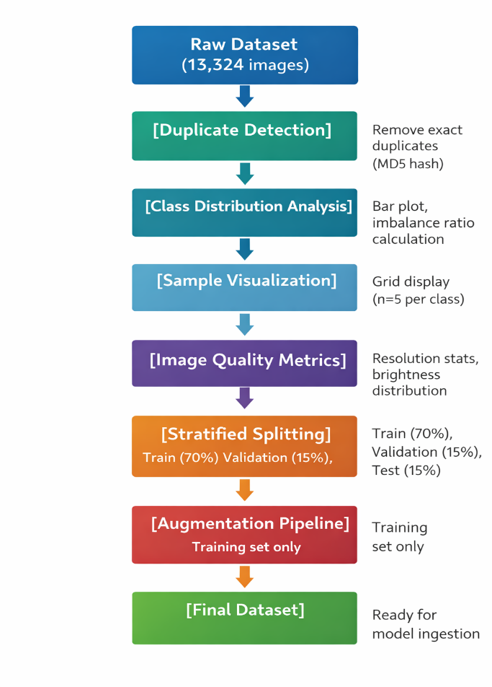
EDA Deliverables:
- Class distribution visualization with count annotations
- Imbalance ratio calculation (majority class / minority class)
- Sample image grid (5×5 or 5×3 depending on class count)
- Image dimension scatter plot
- Brightness/contrast distribution histograms

3.5 Model Architecture Design
Table 3.5: Comparative Model Architecture Specifications
Table
Specification | Custom CNN (Baseline) | MobileNetV2 | EfficientNetB0
Type | From-scratch | Transfer learning | Transfer learning
Parameters | ~1.2M | 3.5M (fine-tuned: ~0.5M) | 5.3M (fine-tuned: ~0.6M)
Depth | 8 layers | 53 layers | 82 layers
Input Size | 224×224×3 | 224×224×3 | 224×224×3
Pre-trained | No | ImageNet | ImageNet
Fine-tuning | N/A | Top 20 layers | Top 30 layers
Expected Accuracy | 75-85% | 88-93% | 90-95%
Inference Time | ~50ms | ~35ms | ~45ms
Model Size | ~5MB | ~12MB | ~20MB
Table 3.6: Custom CNN Layer Configuration
Table
Layer | Type | Filters/Units | Kernel Size | Activation | Output Shape
Input | — | — | — | — | (224, 224, 3)
Conv1 | Conv2D | 32 | 3×3 | ReLU | (224, 224, 32)
Pool1 | MaxPool2D | — | 2×2 | — | (112, 112, 32)
Conv2 | Conv2D | 64 | 3×3 | ReLU | (112, 112, 64)
Pool2 | MaxPool2D | — | 2×2 | — | (56, 56, 64)
Conv3 | Conv2D | 128 | 3×3 | ReLU | (56, 56, 128)
Pool3 | MaxPool2D | — | 2×2 | — | (28, 28, 128)
Flatten | Flatten | — | — | — | (100,352)
Dense1 | Dense | 128 | — | ReLU | (128)
Dropout | Dropout | — | — | — | (128)
Output | Dense | 14 | — | Softmax | (14)

Table 3.7: Transfer Learning Configuration
Table
Component | MobileNetV2 | EfficientNetB0
Base Model | MobileNetV2(weights='imagenet') | EfficientNetB0(weights='imagenet')
Frozen Layers | First 100 layers (feature extraction) | First 100 layers (feature extraction)
Fine-tuned Layers | Last 53 layers (classification refinement) | Last 82 layers (classification refinement)
Custom Head | GlobalAveragePooling2D → Dense(128) → Dropout(0.5) → Dense(14, softmax) | GlobalAveragePooling2D → Dense(128) → Dropout(0.5) → Dense(14, softmax)
Unfreezing Schedule | Epoch 10: Unfreeze top 20 layers, LR/10 | Epoch 10: Unfreeze top 30 layers, LR/10

3.6 Training Configuration and Hyperparameters
Table 3.8: Training Hyperparameters
Table
Parameter | Custom CNN | Transfer Learning | Rationale
Optimizer | Adam | Adam | Adaptive learning rates
Initial LR | 0.001 | 0.0001 (frozen), 0.00001 (fine-tuning) | Prevent catastrophic forgetting
LR Decay | ReduceLROnPlateau (factor=0.2, patience=3) | ReduceLROnPlateau (factor=0.2, patience=3) | Adaptive convergence
Batch Size | 32 | 32 | Memory optimization
Epochs | 50 | 30 (10 frozen + 20 fine-tuning) | Early stopping
Early Stopping | Patience=5, monitor=val_loss | Patience=5, monitor=val_loss | Prevent overfitting
Class Weights | Compute from training distribution | Compute from training distribution | Handle imbalance
Loss Function | Categorical Crossentropy | Categorical Crossentropy | Multi-class standard

Training Infrastructure:
- Primary: Google Colab (T4 GPU, 15GB RAM)
- Fallback: Local development (CPU with reduced batch size)
- Checkpointing: Save best model only (val_accuracy)

3.7 Evaluation Metrics and Model Selection
Table 3.9: Evaluation Metrics with Formulas
Table
Metric | Formula | Application | Target
Accuracy | 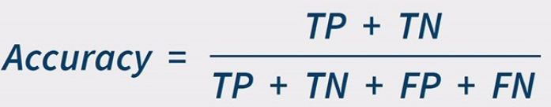 | Overall performance | >0.90
Precision (macro) | 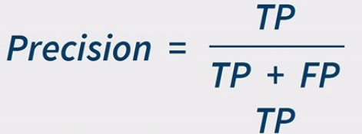 | Minimize false alarms | >0.85
Recall (macro) | 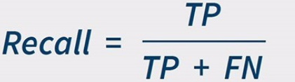 | Capture all diseases | >0.85
F1-Score (macro) | 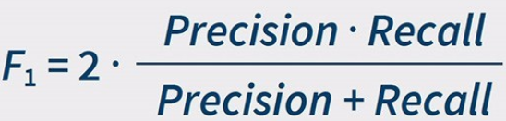 | Balanced measure | >0.85
F1-Score (weighted) | 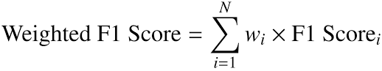 | Imbalance handling | >0.87
Cohen's Kappa | 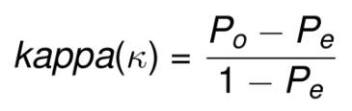 | Agreement beyond chance | >0.80

Figure 3.3: Model Comparison and Selection Process
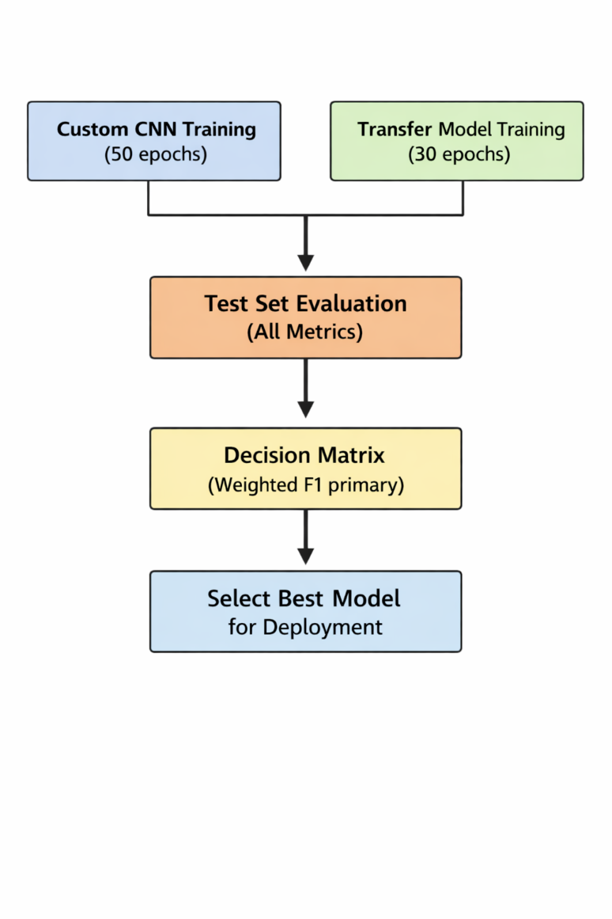
Table 3.10: Model Selection Decision Matrix
Table
Criterion | Weight | Custom CNN | MobileNetV2 | EfficientNetB0
Weighted F1-Score | 40% | Score×0.4 | Score×0.4 | Score×0.4
Inference Speed | 25% | Score×0.25 | Score×0.25 | Score×0.25
Model Size | 20% | Score×0.20 | Score×0.20 | Score×0.20
Training Stability | 15% | Score×0.15 | Score×0.15 | Score×0.15
Total | 100% | Sum | Sum | Sum

3.8 Deployment Architecture
Table 3.11: Streamlit Application Feature Specifications
Table
Feature | Description | Technical Implementation
Image Upload | Drag-and-drop or file selector | st.file_uploader() with type=['jpg','jpeg','png']
Preprocessing Preview | Display resized/normalized image | st.image() with caption
Prediction Display | Class name, confidence percentage | st.success() with formatted string
Confidence Visualization | Progress bar or gauge chart | st.progress() or Plotly gauge
Top-3 Predictions | Secondary class probabilities | st.expander() with bar chart
Advisory Message | Rule-based recommendation | Dictionary mapping class→advice
History Log | Session-based prediction record | st.session_state list

Figure 3.4: Streamlit Application Interface Mockup
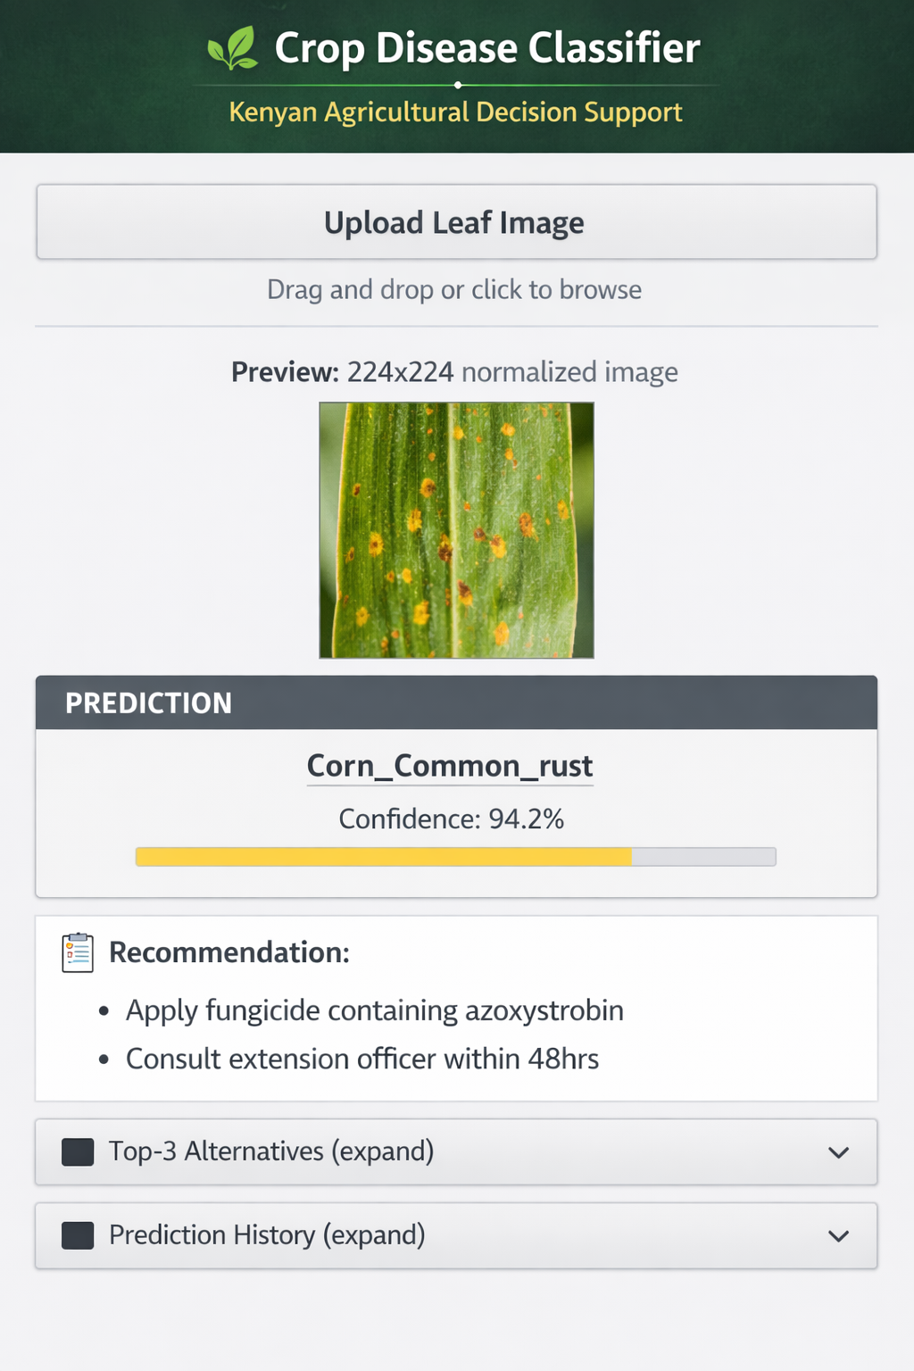

Advisory Rule Base (Example):
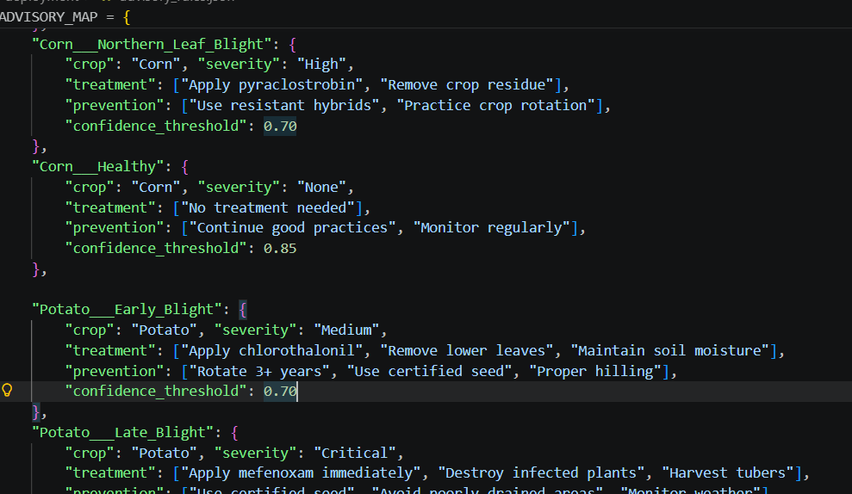
3.9 Ethical Considerations
- Data Provenance: Dataset utilization complies with CC BY-NC-SA 4.0 public domain license; no personal or sensitive agricultural data involved
- Algorithmic Transparency: Confidence scores provided to indicate prediction uncertainty; users informed of model limitations
- Non-replacement Disclaimer: System explicitly positioned as decision support, not replacement for agricultural experts
- Accessibility: Zero-cost deployment ensures equitable access regardless of economic status
- Environmental Impact: Digital diagnosis reduces unnecessary pesticide application through targeted treatment recommendations

CHAPTER 4: IMPLEMENTATION PLAN AND PROJECT MANAGEMENT
4.1 System Development Life Cycle
This project adopts a hybrid Agile-CRISP-DM methodology, combining data mining rigor with iterative development flexibility.
Table 4.1: Agile-CRISP-DM Hybrid Methodology
Table
Phase | CRISP-DM Stage | Agile Sprint | Duration | Deliverables
1 | Business Understanding | Sprint 0 | 2 days | Stakeholder map, success criteria
2 | Data Understanding | Sprint 1 | 2 days | EDA notebook, data quality report
3 | Data Preparation | Sprint 2 | 2 days | Preprocessed datasets, augmentation pipeline
4 | Modeling | Sprint 3-4 | 4 days | Two trained models, training logs
5 | Evaluation | Sprint 5 | 3 days | Comparative analysis, selected model
6 | Deployment | Sprint 6 | 3 days | Streamlit app, documentation
Daily Standups: 15-minute progress reviews
Sprint Reviews: End-of-phase deliverable demonstration
Retrospectives: Post-modeling and post-deployment process improvement

4.2 Work Breakdown Structure and Timeline
Figure 4.1: Gantt Chart - 3-Week Project Timeline
WEEK 1: DATA & PREPARATION
Day 1-2: [Business Understanding][Data Collection Verification]
Day 3-4: [EDA][Data Quality Assessment]
Day 5-7: [Preprocessing Pipeline][Augmentation Implementation]

WEEK 2: MODELING
Day 8-10: [Custom CNN Development][Baseline Training]
Day 11-13: [Transfer Learning Setup][Fine-tuning]
Day 14: [Initial Evaluation]

WEEK 3: EVALUATION & DEPLOYMENT
Day 15-16: [Comparative Analysis][Model Selection]
Day 17-19: [Streamlit Development][UI/UX Refinement]
Day 20-21: [Testing][Documentation][Presentation Prep]

Table 4.2: Phase-Based Work Plan (3-Week Timeline)
Table
Phase | Activity | Duration | Start | End | Deliverable | Responsible
1.1 | Dataset verification & Kaggle download | 0.5 day | Day 1 | Day 1 | Verified dataset | All
1.2 | EDA: Class distribution, sample visualization | 1 day | Day 1 | Day 2 | EDA notebook | Jedidiah
1.3 | EDA: Quality check, duplicate detection | 0.5 day | Day 2 | Day 2 | Quality report | Pauline
1.4 | Data preprocessing pipeline | 1 day | Day 3 | Day 4 | Preprocessing scripts | Dave
1.5 | Stratified splitting implementation | 0.5 day | Day 4 | Day 4 | Split datasets | Dave
1.6 | Augmentation pipeline | 0.5 day | Day 5 | Day 5 | Augmentation generator | Pauline
2.1 | Custom CNN architecture design | 0.5 day | Day 6 | Day 6 | Architecture diagram | Jedidiah
2.2 | Custom CNN training | 2 days | Day 7 | Day 8 | Trained baseline | Jedidiah
2.3 | Transfer learning setup (MobileNetV2) | 1 day | Day 9 | Day 9 | Frozen model | Dave
2.4 | Transfer learning fine-tuning | 2 days | Day 10 | Day 11 | Fine-tuned model | Dave
2.5 | EfficientNetB0 alternative training | 2 days | Day 10 | Day 11 | Alternative model | Pauline
3.1 | Comprehensive evaluation metrics | 1 day | Day 12 | Day 12 | Evaluation report | All
3.2 | Model comparison and selection | 1 day | Day 13 | Day 13 | Selected model | All
3.3 | Model optimization (quantization if needed) | 0.5 day | Day 14 | Day 14 | Optimized model | Dave
4.1 | Streamlit interface design | 0.5 day | Day 15 | Day 15 | UI mockup | Pauline
4.2 | Streamlit backend integration | 1 day | Day 16 | Day 17 | Functional app | Pauline
4.3 | Advisory system integration | 0.5 day | Day 17 | Day 17 | Rule engine | Pauline
4.4 | Testing and bug fixes | 1 day | Day 18 | Day 19 | Tested application | All
5.1 | Technical documentation | 0.5 day | Day 19 | Day 19 | README, code docs | Dave
5.2 | Final report compilation | 0.5 day | Day 20 | Day 20 | Project report | All
5.3 | Presentation preparation | 0.5 day | Day 20 | Day 21 | Slides | All

4.3 Resource Requirements and Budget
Table 4.3: Resource Requirements and Budget
Table
Category | Item | Specification | Cost (KES) | Cost (USD)
Computing | Google Colab Pro | T4 GPU, 15GB RAM (optional upgrade) | 0 / 2,500/mo | 0 / 20
 | Local development | Laptop with 8GB+ RAM | Sunk cost | Sunk cost
Data | Kaggle Dataset | New Plant Diseases Dataset | 0 | 0
 | Internet bandwidth | ~5GB download/upload | 500 | 4
Software | Python ecosystem | TensorFlow, Keras, Streamlit | 0 | 0
 | Development IDE | VS Code, Jupyter | 0 | 0
 | Version control | GitHub (public repo) | 0 | 0
Deployment | Streamlit Cloud | Free tier (public apps) | 0 | 0
 | Alternative: Heroku | Free tier (if needed) | 0 | 0
Documentation | Overleaf/LaTeX | Free academic version | 0 | 0
 | Diagram tools | draw.io, Figma (free) | 0 | 0
Contingency | Additional compute | If Colab limits reached | 1,000 | 8
TOTAL |  |  | 1,500 | ~12

Resource Access Strategy:
- Primary compute: Google Colab free tier (T4 GPU)
- Backup: Local CPU training with reduced batch size
- Collaboration: GitHub repository with branch protection
- Communication: WhatsApp group + weekly google meet calls

4.4 Risk Assessment and Mitigation
Figure 4.2: Risk Probability-Impact Matrix
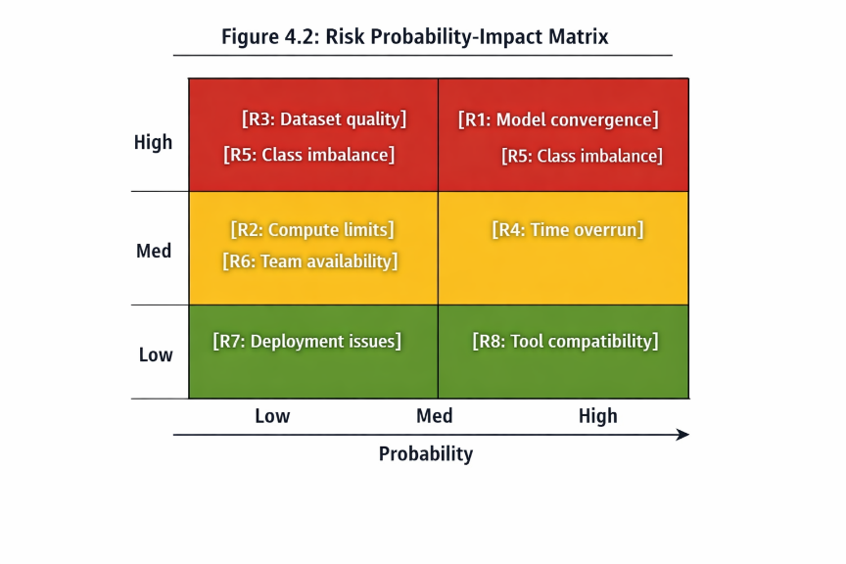
Impact]

Table 4.4: Risk Assessment Matrix
Table
ID | Risk | Probability | Impact | Mitigation Strategy | Owner
R1 | Model fails to converge (accuracy <70%) | Medium | High | Early stopping, LR tuning, architecture simplification | Jedidiah
R2 | Google Colab GPU limits exceeded | Medium | Medium | Local CPU fallback, reduced batch size, checkpointing | Dave
R3 | Dataset quality issues (noise, mislabeling) | Low | High | EDA quality gates, manual sample inspection | Pauline
R4 | Timeline overrun due to complexity | Medium | Medium | Agile sprints, MVP prioritization, scope freeze | All
R5 | Severe class imbalance affecting minority classes | High | Medium | Class weights, stratified sampling, F1-focused evaluation | Dave
R6 | Team member availability constraints | Low | Medium | Task parallelization, documentation handoffs, daily standups | All
R7 | Streamlit deployment technical issues | Low | Low | Local testing, alternative Heroku deployment, containerization | Pauline
R8 | Library version conflicts | Low | Low | Requirements.txt, virtual environments, Colab consistency | Jedidiah

4.5 Expected Deliverables and Outcomes
Table 4.5: Deliverables Checklist
Table
Category | Deliverable | Format | Due Date | Success Criteria
Data | EDA Notebook | Jupyter (.ipynb) | Day 3 | Visualizations, class stats, quality report
 | Preprocessing Pipeline | Python scripts | Day 5 | Reproducible, documented, tested
Model | Custom CNN | SavedModel/H5 | Day 8 | >75% validation accuracy
 | Transfer Learning Model | SavedModel/H5 | Day 11 | >88% validation accuracy
 | Comparative Analysis Report | PDF/Markdown | Day 13 | Metrics table, confusion matrices, selection rationale
Application | Streamlit App | Python (.py) + requirements | Day 18 | Functional, <2s inference, confidence display
 | Advisory Rule Base | JSON/Python dict | Day 17 | 14 class entries, actionable recommendations
Documentation | Technical README | Markdown | Day 19 | Setup instructions, architecture overview
 | Final Project Report | PDF (this document) | Day 20 | Complete, formatted, referenced
 | Presentation Slides | PowerPoint/PDF | Day 21 | 10-15 slides, demo video backup
Repository | GitHub Repository | Public/Private | Day 21 | Organized, documented, reproducible

Success Metrics:
- Technical: Weighted F1-score ≥0.87 on held-out test set
- Usability: Streamlit app functional with <2 second inference time
- Accessibility: Zero deployment cost, accessible via standard smartphone browser
- Documentation: Complete reproduction possible from repository alone
4.6 Limitations and Future Research Directions
Table 4.6: Limitations and Mitigation Strategies
Table
Limitation | Description | Impact | Mitigation | Future Research
L1: Controlled imagery | Kaggle dataset uses lab-controlled backgrounds and lighting | Reduced generalization to field conditions | Augmentation, brightness normalization | Collect Kenyan field imagery for domain adaptation
L2: Disease stage specificity | Dataset contains visible symptoms, not early-stage detection | Cannot identify pre-symptomatic infections | Clear user communication about visible symptoms | Spectral imaging for pre-symptomatic detection
L3: Geographic specificity | Model trained on international dataset, not Kenya-specific | Potential performance variation on local varieties | Include Kenyan varieties in future training | Partnership with KALRO for local data collection
L4: Pest exclusion | Dataset contains diseases only, no pest classification | Incomplete agricultural diagnostic | Scope limitation clearly stated | Integration with pest detection datasets
L5: Connectivity dependency | Streamlit requires internet connection | Limited offline usability | Lightweight model for future mobile deployment | TensorFlow Lite conversion for offline mobile app
L6: Language barrier | Interface in English only | Reduced accessibility for non-English speakers | Swahili advisory translations in Phase 2 | Full Swahili interface localization
L7: Expertise boundary | Model provides class prediction, not treatment protocols | Risk of misinterpretation | Explicit decision support disclaimer, not replacement | Integration with agricultural knowledge bases

Future Research Roadmap:
Table
Phase | Timeline | Focus | Extension
Phase 2 | +3 months | Dataset expansion | Add sugarcane and rice; collect Kenyan field images
Phase 3 | +6 months | Mobile deployment | TensorFlow Lite Android app with offline capability
Phase 4 | +12 months | Pest integration | Object detection (YOLO) for insect pest identification
Phase 5 | +18 months | Multimodal system | Integrate weather data for disease risk prediction
Phase 6 | +24 months | Expert system | NLP interface for farmer queries, voice input in Swahili

REFERENCES
- Shubham Sharma (2023). Five Crop Diseases Dataset https://www.kaggle.com/datasets/shubham2703/five-crop-diseases-dataset
- Central Bank of Kenya. (2025). Agricultural Sector Survey Report 2025. Nairobi: CBK.
- Davis, F. D. (1989). Perceived usefulness, perceived ease of use, and user acceptance of information technology. MIS Quarterly, 13(3), 319-340.
- Ferentinos, K. P. (2018). Deep learning models for plant disease detection and diagnosis. Computers and Electronics in Agriculture, 145, 311-318.
- Howard, A. G., et al. (2017). MobileNets: Efficient convolutional neural networks for mobile vision applications. arXiv:1704.04861.
- Hughes, D. P., & Salathé, M. (2015). An open access repository of images on plant health to enable the development of mobile disease diagnostics. arXiv:1511.08060.
- Krizhevsky, A., Sutskever, I., & Hinton, G. E. (2012). ImageNet classification with deep convolutional neural networks. NIPS, 1097-1105.
- LeCun, Y., et al. (1998). Gradient-based learning applied to document recognition. Proceedings of the IEEE, 86(11), 2278-2324.
- Mohanty, S. P., Hughes, D. P., & Salathé, M. (2016). Using deep learning for image-based plant disease detection. Frontiers in Plant Science, 7, 1419.
- Mose, L., et al. (2023). Agricultural extension in Kenya's devolved system: Challenges and opportunities. Journal of Agricultural Education and Extension, 29(2), 123-145.
- Ramcharan, A., et al. (2017). Deep learning for image-based cassava disease detection. Frontiers in Plant Science, 8, 1852.
- Sandler, M., et al. (2018). MobileNetV2: Inverted residuals and linear bottlenecks. CVPR, 4510-4520.
- Tan, M., & Le, Q. (2019). EfficientNet: Rethinking model scaling for convolutional neural networks. ICML, 6105-6114.
- Venkatesh, V., et al. (2003). User acceptance of information technology: Toward a unified view. MIS Quarterly, 27(3), 425-478.
APPENDICES
Appendix A: Dataset Class Inventory
Table
# | Class Name | Crop | Status | Image Count | Train | Val | Test
1 | Corn___Common_Rust | Corn | Diseased | 1192 | 70% | 15% | 15%
2 | Corn___Gray_Leaf_Spot | Corn | Diseased | 913 | 70% | 15% | 15%
3 | Corn___Healthy | Corn | Healthy | 1162 | 70% | 15% | 15%
4 | Corn___Northern_Leaf_Blight | Corn | Diseased | 985 | 70% | 15% | 15%
5 | Potato___Early_Blight | Potato | Diseased | 1000 | 70% | 15% | 15%
6 | Potato___Late_Blight | Potato | Diseased | 1000 | 70% | 15% | 15%
7 | Potato___Healthy | Potato | Healthy | 152 | 70% | 15% | 15%
8 | Wheat___Brown_Rust | Wheat | Diseased | 902 | 70% | 15% | 15%
9 | Wheat___Healthy | Wheat | Healthy | 1116 | 70% | 15% | 15%
10 | Wheat___Yellow_Rust | Wheat | Diseased | 924 | 70% | 15% | 15%
Total |  |  |  | 13,324

Appendix B: Model Architecture Diagrams
[To be inserted: Visual diagrams of Custom CNN, MobileNetV2 fine-tuning setup, and EfficientNetB0 architecture]

Appendix C: Evaluation Metrics Formulas
Precision (per class):

Recall (per class):

F1-Score (per class):

Macro F1-Score:

Weighted F1-Score:

Where = support (number of true instances) for class i

